



**SM6P07NI Digital Media Project**

**20% Research and Proposal**

**2022-23 Winter**

**Student Name: Ashraya Singh Khatri**

**London Met ID: 19031980**

**College ID: NP01MM4A190077**

**External Supervisor: Pooja Shrestha**

**Internal Supervisor Rakshak Bhushan Bajracharya**

**Assignment Due Date: Wednesday, December 28, 2022**

**Assignment Submission Date: Wednesday, December 28, 2022**

**Word Count: 2954**

*I confirm that I understand my coursework needs to be submitted online via Google Classroom under the relevant module page before the deadline in order for my assignment to be accepted and marked. I am fully aware that late submissions will be treated as non-submission and a marks of zero will be awarded.*

**Abstract**

This documentation gives a brief overview of the research and development aspect of the project for Digital Media Project (DMP). The content of this document provides a thorough explanation to the topic of the DMP, i.e., Low Poly Game Assets. It further explains the use of low poly modelling by indie game developers and it’s rise in the video game industry.

In the field of gaming industry and 3D animation low poly modelling has been an art from the very beginning since low polygonal resolution helps to reduce the render time and greatly speeds up the processing time to model the characters and props. Indie game developers these days mostly choose to create a game with low poly art has it gives them more time to model them and aren’t bothered by deadlines. Artists love to create their own 3D world, but not everyone knows how to model, so they download pre-made assets from resources like Unity or Synty studios. By using these assets, they can customize their scenes as they want and focus on other aspects like lightning, compositing, as can work on their work.

The following documentation contains the research to create a low poly stylized asset used for games. With the help of my supervisors, Rakshak Sir and Pooja Ma’am, I was able to finalize my concepts. My concept for DMP is to create low poly animations and models as assets to be used in-game development. This project will showcase all the research, and software to complete the project.

Contents

Introduction 1

Topic 2

Aims of Project 3

1.2 Area of Research 4

3. Target Audience 5

3.1 Primary Target Audience: Game Designers/ Indie Artist 5

3.2 Secondary Target Audience: Gamers 5

4. Product Research 6

9

5. Technologies employed 10

6. Project Plan 11

Changes in the Plan 12

7. Production Phases 12

Game development Life Cycle 12

8 Resources 14

**Table of Figures**

# Introduction

This document carries a brief overview of the second coursework for the module “Digital Media Project (SM6P07NI)”. The course covers 50% of the total assessment weight. For this semester the students are required to complete their individual projects and provide their internal and external supervisors the documentation, project files and google drive folder link which should contain overall production process, evidence, and testing of the project.

As mentioned in the previous document, the field of gaming development is a very vast one. But as the future for the gaming industry is on the rise, so have the artists. Many new and upcoming game developers are trying and making their own games. As an Indie game developer, they share knowledge, research and feedback, provide testing for one another. Therefore, this documentation covers the research and knowledge of an individual for creating game assets. It further covers the target audience, the software used, and the resources and techniques used to complete the project.

# Topic

Stylized Low Poly Assets

The topic for my project is “Stylized Low Poly Assets” was inspired by numerous low poly asset packs which were being placed up by Asset artist who were creating amazing and entertaining looking assets for people to enjoy. It contains various different asset pack with different genre for everyone to enjoy.

The overall goal of the project is to provide multiple asset packs to individuals so that they can modify their own games utilizing these pre-made models. The project includes eight different asset pack that can be used in a variety of different game settings and environments. These low poly assets pack include 3D models, animation, special effects and particle effects. They’re awesome way to keep the games art looking consistent. The stylized art style gives it a unique visual design.

# Aims of Project

The aim of the project “Stylized Low Poly Asset’ is to simply create a low poly asset pack for the user, as it would lessen their production time and they will be able to finish their project in a faster and efficient way. Since there is rise of many assets’ packs in the internet this not only helps the user to save their time and increase their productivity, it also allows other who don’t have skills in the field of 3D and want to engage in it.

There is a production phases to create assets. There is the pre-production phase where the concept art, storyboard, references and functionality of the game is decided. After the finalization of the concept, during the production phases the production of the project is started. The process of creating assets includes, modelling mapping, UV baking, texturing, shading, lightning and compositing. So, there are many processes out there in the field of 3D. It is very vast and needs a deep level of creativity and understanding which might be time consuming and hard for many. Thus, the market of assets being available as a valuable research are very growing in the video game industry.

The low poly stylized asset includes a variety of different modular meshes, including campfire, outer space ship animation loop, car loop animation, tavern dungeon model and weapon packs. This allows the user to easily modify their game environment without having to focus on modeling and texturing. Low Poly is becoming more and more popular amongst Indie game developers’ theses days, since it is less expensive and easier to create a game on. It decreases their cost and helps boost their production time and quality of the game. They can focus more on their game without worrying about their deadline and boost the quality of the game.

The goal of this project is to make a specific set of stylized assets that an Indie game developer can use it. If a game developer or a player who wants to mod their games or required assets which can be used in certain different gaming scenarios, then this is where the collection of the stylized asset pack comes to play. This helps the game to be more customizable and make the game look unique and beautiful by adding the personalized assets.

Finally, the key objective of this asset pack is to assist the game designers and people who want to learn and utilize more 3D as a stylish game packs that are easily usable and customizable. I hope that the project will also motivate more individuals to learn and experiment with 3D modelling and animation, as well as develop their own unique and creative products.

## Area of Research

The field of game industry is a very vast one. So, the amount of research and creativity is a very large one as well. Form modelling, lightning, texturing, to worldbuilding these topics had to be properly researched before starting the project. Firstly, I researched reference for the modeling.

After I properly researched and used the reference for modeling and started the process. Since, my shading is stylized low poly I began researching and collecting references for it as well. Thus, the research for modeling includes witch’s brew, dungeons, rockets, etc. In addition to the modelling, I wanted to provide animation loop for user could use in their required scenario.

As to further stylize the assets of specific shader there had to be followed to specific modeling with low sculpting and lightning to give it that look. After all the assets and textures that was created for the project were assembled in Blender. Therefore, there was extensive research for the use of the software with proper knowledge of lightning, texturing, shader setup.

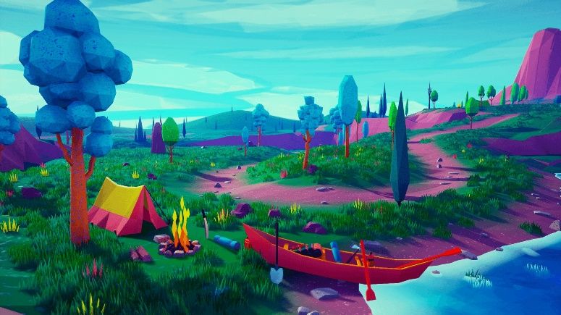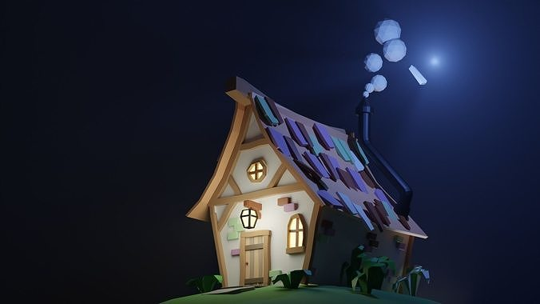

In the images above, on the first one we can see it shows a stylized house with a dark background that focuses and brings more detail to the cottage. As seen in the second image, there is a campfire in the forest with several different color palettes, and the model is utilized as a single material and a texture map with a number of color palettes arranged. So, as such being inspired from this style I haven taken them as a refence for the project.

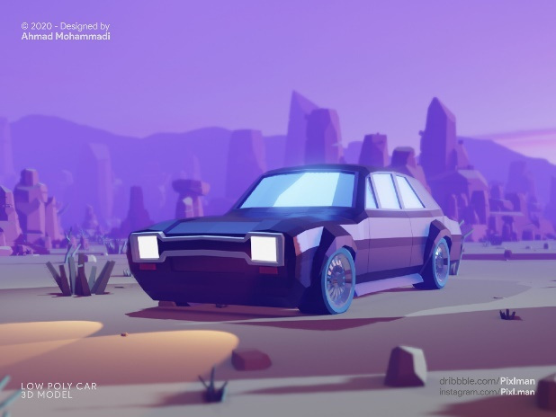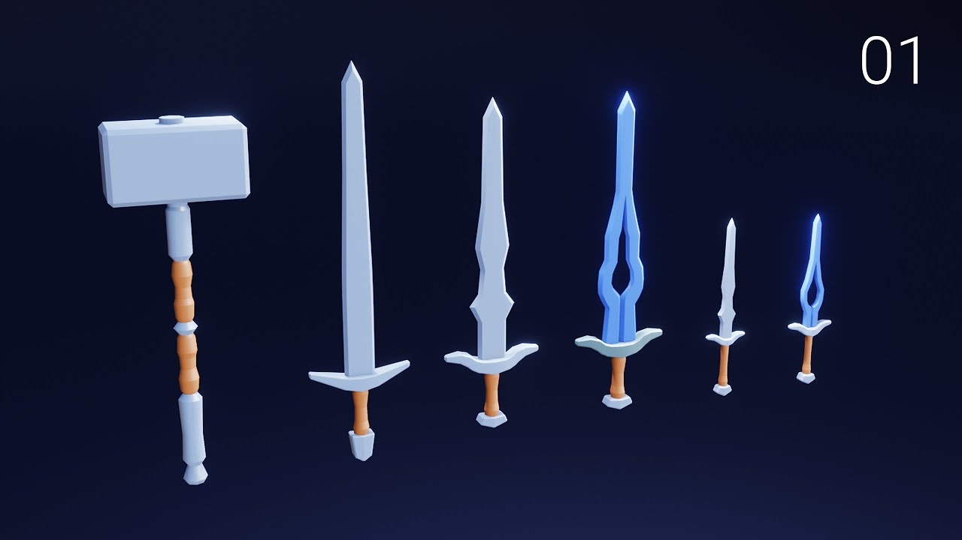

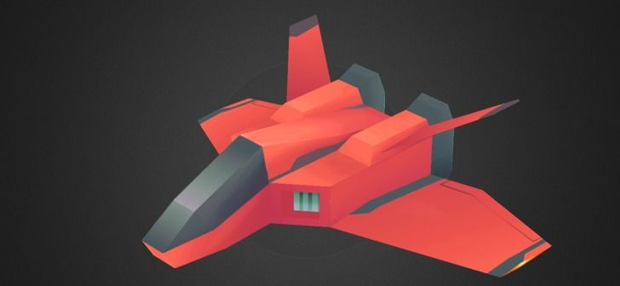

So, to model and animate different asset packs for various game scenarios, I have researched on various low poly models and watched videos and studies about them. Form the above references images, I got the idea and inspiration to model my assets for the project.

# 3. Target Audience

Identifying a target audience is very essential in a project production, there are two distinct audiences which have been researched for this project. Their details have been approached as follows:

## 3.1 Primary Target Audience: Game Designers/ Indie Artist

**Age:** 15 + above

**Gender:** All genders

**Ethnicity:** All Ethnic group of people

**Location:** Throughout the world

**Genre Specification:** Stylized Low Poly pack

As per the research and objective of the project, the primary targeted audience are comprised of the age group from 15 and above. As the process of creating asset is time consuming and leads to being hectic at times. The process of creating assets can be prove useful for them as they can be used for building their own games. This allows them to utilize their time and focus more on their production.

## 3.2 Secondary Target Audience: Gamers

**Age:** 15 + above

**Gender:** All genders

**Ethnicity:** All Ethnic group of people

**Location:** Throughout the world

**Genre Specification:** Stylized Low Poly pack

As per the research and objective of the project, the secondary targeted audience for the product are gamers or people interested in the field of 3D modelling. As there are gamers or viewers who want to use different 3D modelling software to customize their games. In gaming Industry modification of a game is very popular. Gamers or modders can use the assets and customize the games as their choice and release it in the market.

# 4. Product Research

While researching the contents for my DMP, I came across a new software that was not taught to us here in college. I used Blender to complete my project, and I acquired many new tools and techniques from there which I have employed in my project.

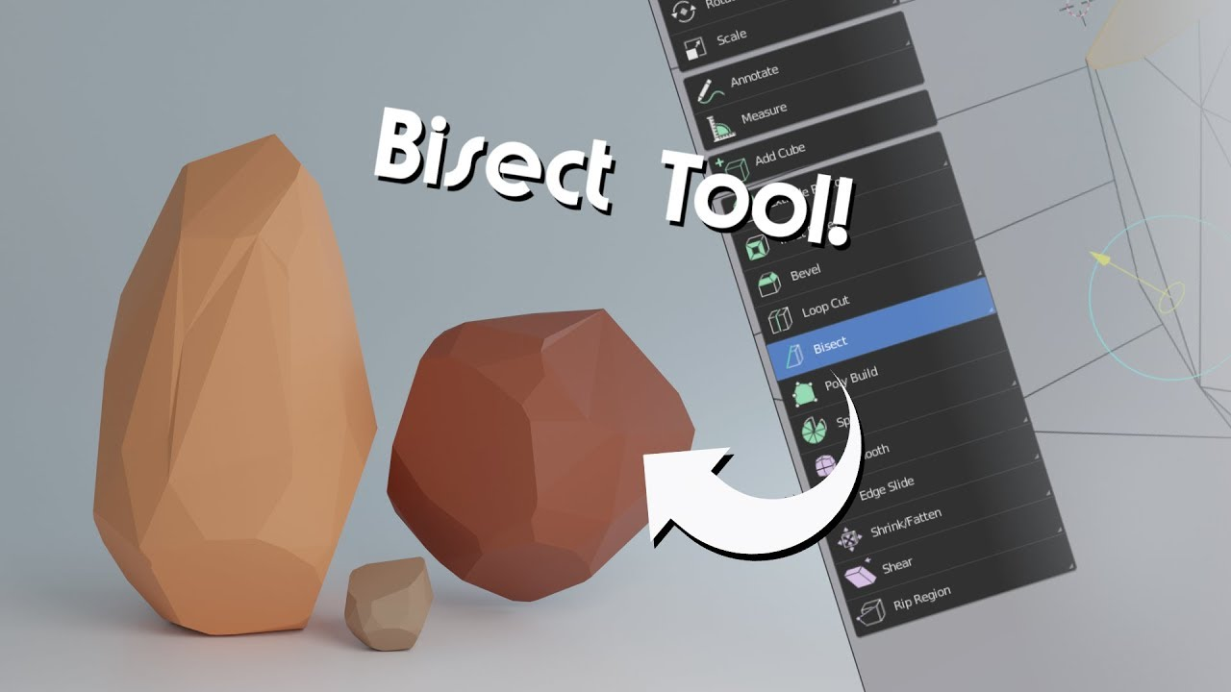

As I started Blender, I leaned many new tools and techniques. One of the common tools that I used to make low poly stones is Bisect tool. It helps in a quick way to cut a mesh in two along a common line.

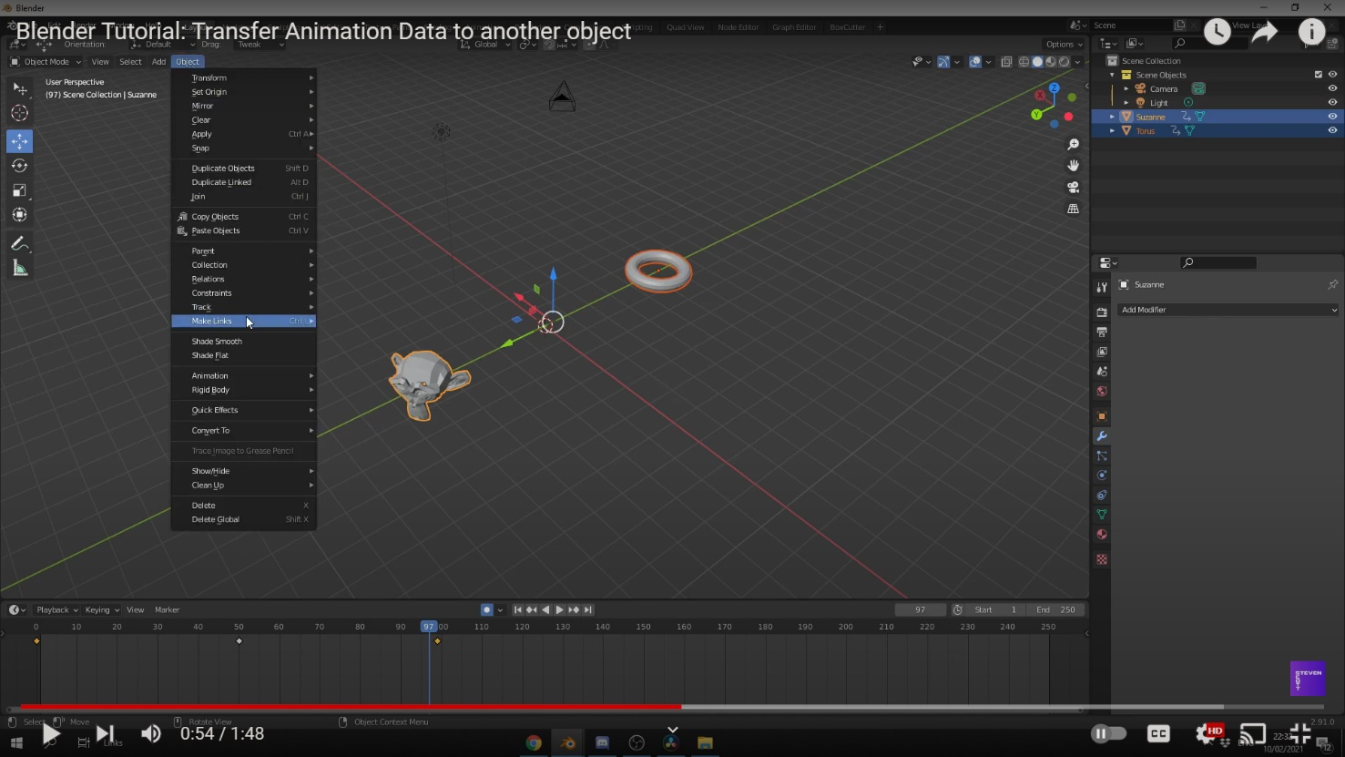

Since, I am also making short animation loops. I learned how to copy and transfer animation data from one object to another. Linking transfers animation data from one mesh to another. The animation data is now linked, changing the animation data in one object also changes the animation on the other.

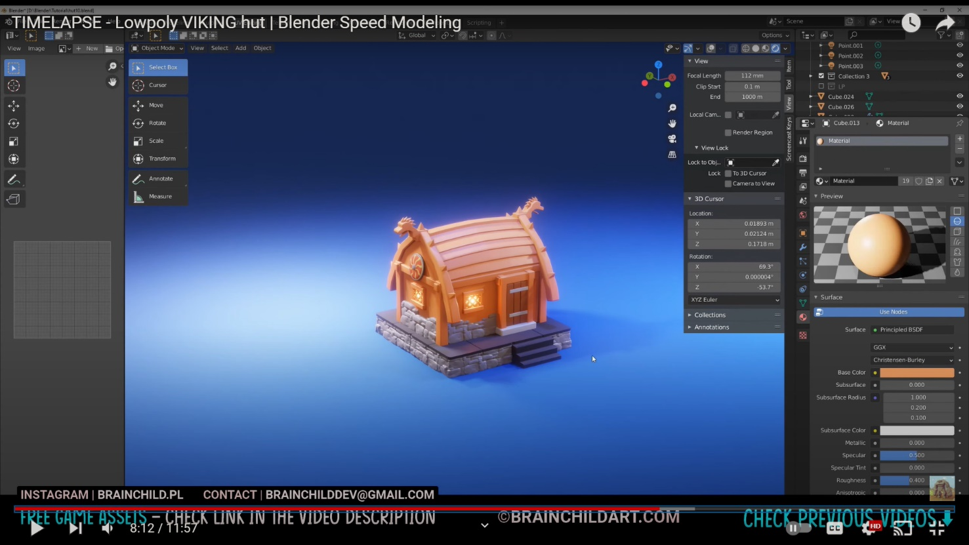

In Blender, materials are the objects that are generated with color, pattern and texture. Shader Editor can be accessed through the Shading tab. The preview is shown on the top screen, while the Shader Editor is shown at the bottom.

# 

If after selecting an object if nothing appears, then then the object lacks material. After clicking the new “+” button at the bottom of screen, a Material is created and a node is automatically created.

The note must be attached is the Material Output node. This node’s connection will be reflected. The default shader is Principal BDSF. The default shader should be disconnected, and after creating another node, drag a line from “BDSF” on the right side of the required node to the material output.

# 5. Technologies employed

Many types of software were utilized to finish the project. These software were used for modeling, texturing, lighting, and compositing.

Blender

Blender is a popular open- source 3D software. It was developed by Ton Roosendaal, a Dutch art director and self-taught software developer. Blender features includes 3D Modelling, animation, UV mapping and baking, texturing, raster graphics editing, rigging and skinning, fluid and smoke simulation, particle simulation, etc. One of there reason of it’s rise is as it supports the entire 3D pipeline.

Blender is the software that will be used to complete most of this coursework. This software will be sued for low poly modelling, animation, lightning, texturing, camera, rendering and so much more. Blender is one of the most unique software that has various tools that can be used to create low poly models. For animation it allows us to work on it rather than sinking time in the models. The environment will be properly lit with one point and three-point lightning. Similarly, the camera movements are going to be used with proper camera angle to match with the shading and lightning of the model. Once the modelling and animation is completed the whole scene will be rendered with proper settings.

Adobe Illustrator

Adobe Illustrator is the industry top graphic editing software, that allows us to produce and edit logos, charts, illustrations, diagrams, photos, and so on. It includes multiple tools for creating and editing vector images. It is the perfect tool for designers and artists to create and edit digital graphics in high precision.

Illustrator will be used while making the base color or gradient layer for different textures, reference images, concept art and vector designs that will be imported in Blender.

Adobe After Effects

Adobe After Effects is one of the industry leading software for graphic designing motion graphics and visual effects for films and video. It is an excellent tool for editing that allows to make animations, and various effects to moving images.

This video compiling software will be used to composite and edit the final rendered video. With different layers in after effects any changes that needs to be done after the final compositing will be done in after effects.

Adobe Premiere Pro

Adobe Premier Pro is a full- featured software that includes cutting edge editing tools, motion graphics, visual effects, animation, and other features to enhance the final video project. The software is also completely compatible with Adobe Illustrator and Adobe After Effects.

Premiere Pro will be used for editing the video and sound. It will also be used to complete the sound effects and arrange the videos. The final edited video will be color corrected and rendered in proper settings.

# 

# 6. Project Plan

Gantt chart

After the timeline for the production of the project was decided, to create a plan to keep track of the process a Gantt chart was designed. The Gant chart also consists of the tasks that were already completed at the pre- production such as concept finalization and storyboard. To show the production of my project plan the Gantt chart displays the overall workflow of the project. All the steps, including modeling, texturing, compositing is further clarified.

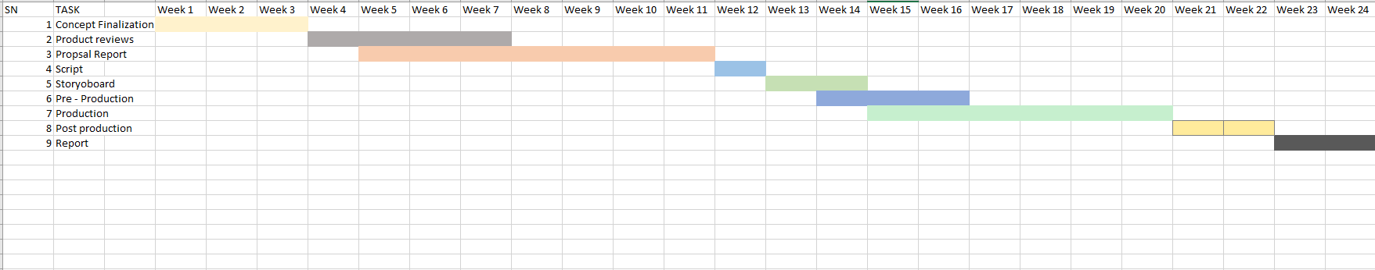

In the timeline and scheduling of the previous coursework, there were lots of process missing and unassigned. This was mainly because at that time the GDLC model process was not followed. However, the work was divided to standard project planning i.e., Preproduction, production, and post-production. The production process was mentioned to start from November of 2021 to May of 2022. Thus, in the second semester this process was reset and started from beginning as more contents and steps were added to the production as per the guidelines of GDLC model.

For the previous timeline of the project, lots of production processes were not properly followed. It was due to lack of a proper model process being not assigned to the project. However, the tasks for the project were divided into standard project planning, Pre-production. Production and Post- production. The production process was mentioned to start from week 15 to week 20. Thus, due to the project not being updated with the previous timeline the initial plan that was done for the DMP was updated with the new Gantt chart.

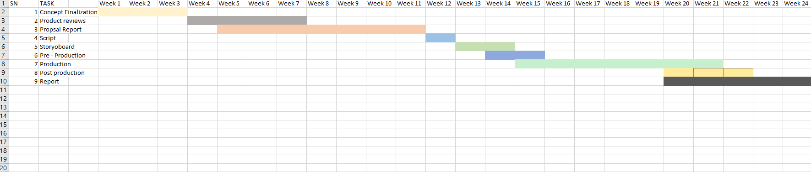

In the early stages, the project was going smoothly. But, with the encounter with some software bugs the project was halted for a while. So, with the new timeline the pre- production process remained same with some changes in the production phase. Following the changes in the model of the production, the contents and scheduling of its processes were matched with the changes. The project contained modelling and animation loops, and I decided to add some particle effects to make it more appealing. So, due to some technical problems and understanding new topics made it time consuming. Thus, the contents and scheduling for the production and prost- production process were updated to match the changes. The production phase duration has increased giving more time to create models with proper shaders and lightning. Post-Production has been moved forward as to render the materials as quickly as possible.

# 7. Production Phases

## Game development Life Cycle

Game Development Life Cycle also known as GDLC is a life cycle of software development with the aim to help the developers follow specific plans to achieve their desired products. Comparing to Software Development Life Cycle (SDLC), developers may face many obstacles while developing games, hence they follow a specific set of planning for developing games.

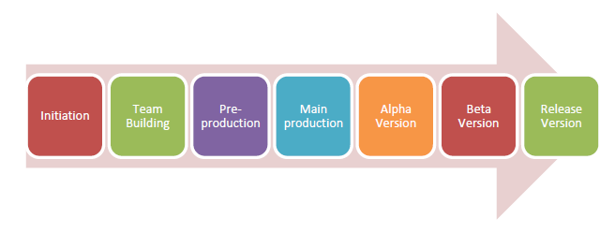

When the game is being released to the general public, GDLC goes through seven different stages, as shown in the above image. The stages are as follows: Firstly, planning what game to produce, deciding on the genre of the game, pre-production: which includes building the

games prototype. The main production includes the games latest version. The alpha version is the unfinished but playable game which is used for alpha testing and fixing bugs and errors. The Beta version is when the game is being tested out by beta tester and released once the bugs are found by the testers and errors have been fixed.

Pre- Production

# 8 Resources

8.1 Hardware and Devices

• Acer Predator Helios 300

• NVIDIA GTX 1650TI GPU

• Intel Core7 9th Gen

8.2 Software

A total of 5 different software was used in the production of this project. All of these software were used for modeling, texturing, lighting, and compositing.

❖ Adobe Photoshop 2021

❖ Adobe Illustrator 2021

❖ Blender 3.4

❖ Substance Painter

❖ Adobe After Effects 2021